# SCIENCE

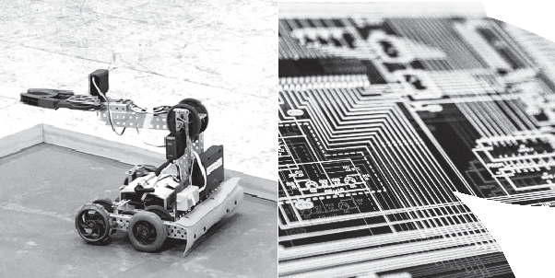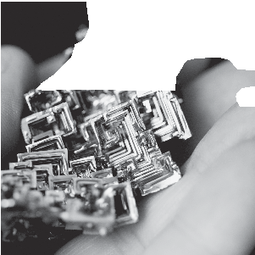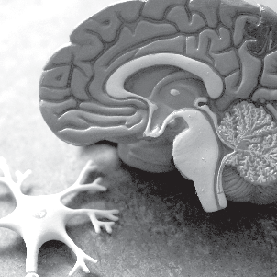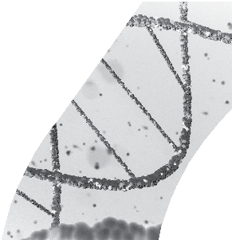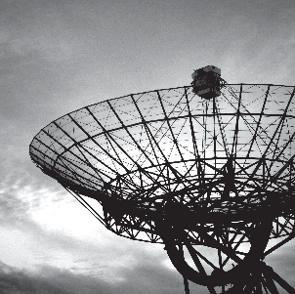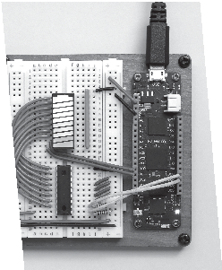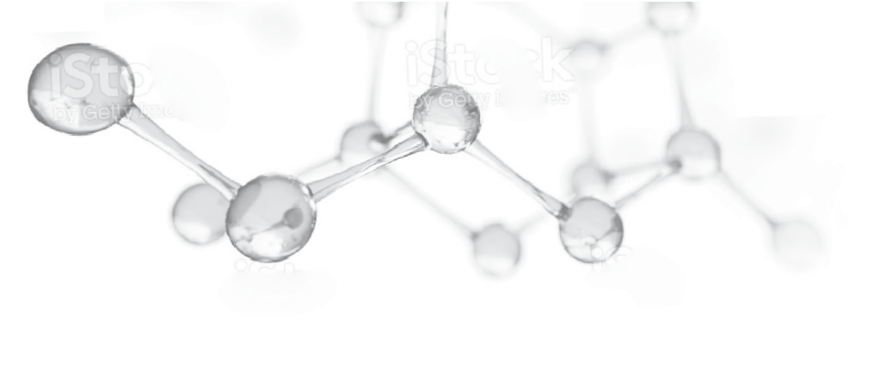

2024 National Tournament

**OLYMPIAD**

|  |  |  |  |  |
| --- | --- | --- | --- | --- |
| **2024 Science Olympiad National Tournament Partner Levels** | | | | |
| **Recognition** | **Sponsor Benefits** | | | |
| **Presenting** | **Spartan** | **Elite** | **Collaborating** |
| $50,000+ (2) | $25,000+ (4) | $5,000+ (16) | $1,000 (unlimited) |
| Opening Ceremony pre-key welcome by representative | Yes |  |  |  |
| Corporate table at Science Olympiad Alumni Dinner | Yes |  |  |  |
| Logo on back cover of event program | Yes |  |  |  |
| Media Interview inclusion | Yes |  |  |  |
| Logo on directional signage across campus | Yes |  |  |  |
| Logo on coach and VIP gifts | Yes |  |  |  |
| Corporate rep VIP seating at Ceremonies | Yes | Yes |  |  |
| STEM Expo Talk - Lecture | Yes | Yes |  |  |
| Logo on back of volunteer t-shirts | Yes | Yes |  |  |
| Logo on polo shirts for officials, supervisors, VIPs | Yes | Yes |  |  |
| Item/insert into all 121 Team Boxes | Yes | Yes |  |  |
| Logo on all promotional advertising | Yes | Yes |  |  |
| Logo on participant and officials' lanyards | Yes | Yes |  |  |
| Representative presents medals on stage at Awards | Yes | Yes |  |  |
| STEM Expo Booth Space | Yes - Premium | Yes - Large | Yes | Yes |
| Ad in tournament program | Full Page | Half Page | Quarter Page | Eighth Page |
| Logo displayed throughout event & on Jumbotron | Yes | Yes | Yes | Yes |
| Logo displayed at Opening and Awards Ceremonies | Yes | Yes | Yes | Yes |
| Corporate mentions on all social media platforms | Yes | Yes | Yes | Yes |
| Recognition in printed event program | Logo | Logo | Logo | Logo |
| Recognition in web-based event materials | Hyperlinked Logo | Hyperlinked Logo | Hyperlinked Logo | Hyperlinked Logo |
| Name recognized in all press releases | Yes | Yes | Yes | Yes |
| Listed as sponsors in home rooms | Yes | Yes | Yes | Yes |